

SIMATS ENGINEERING

Saveetha Institute of Medical and Technical Sciences
Chennai- 602105

Student Name: Siva Dakshitha K Reg. No.: 192425395
Course Code: CSA1603 Slot: C
Course Name: Data Warehousing & Data Mining
Course Faculty: Dr. D. Beulah David
Project Title: Airline Passenger Analytics using Data Warehouse, ETL, Decision Tree, Bayesian Classification, OLAP Cubes, KNIME, WEKA and Power BI
Module Photographs:
Module Photo  Module 1-Preprocessing & ETL | Individual student contribution module work in the project | Presentation Image
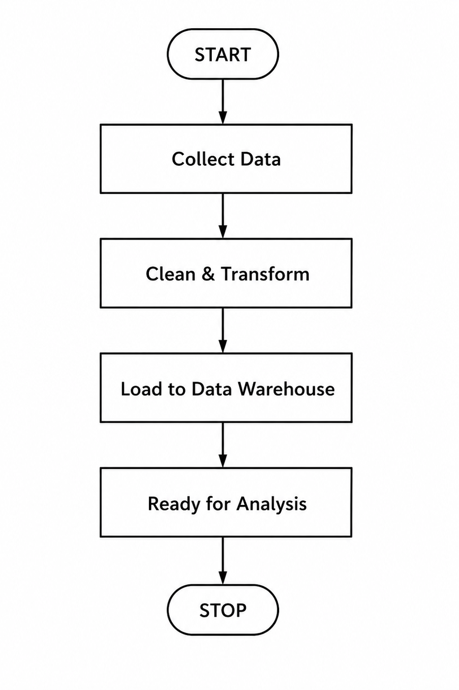 | 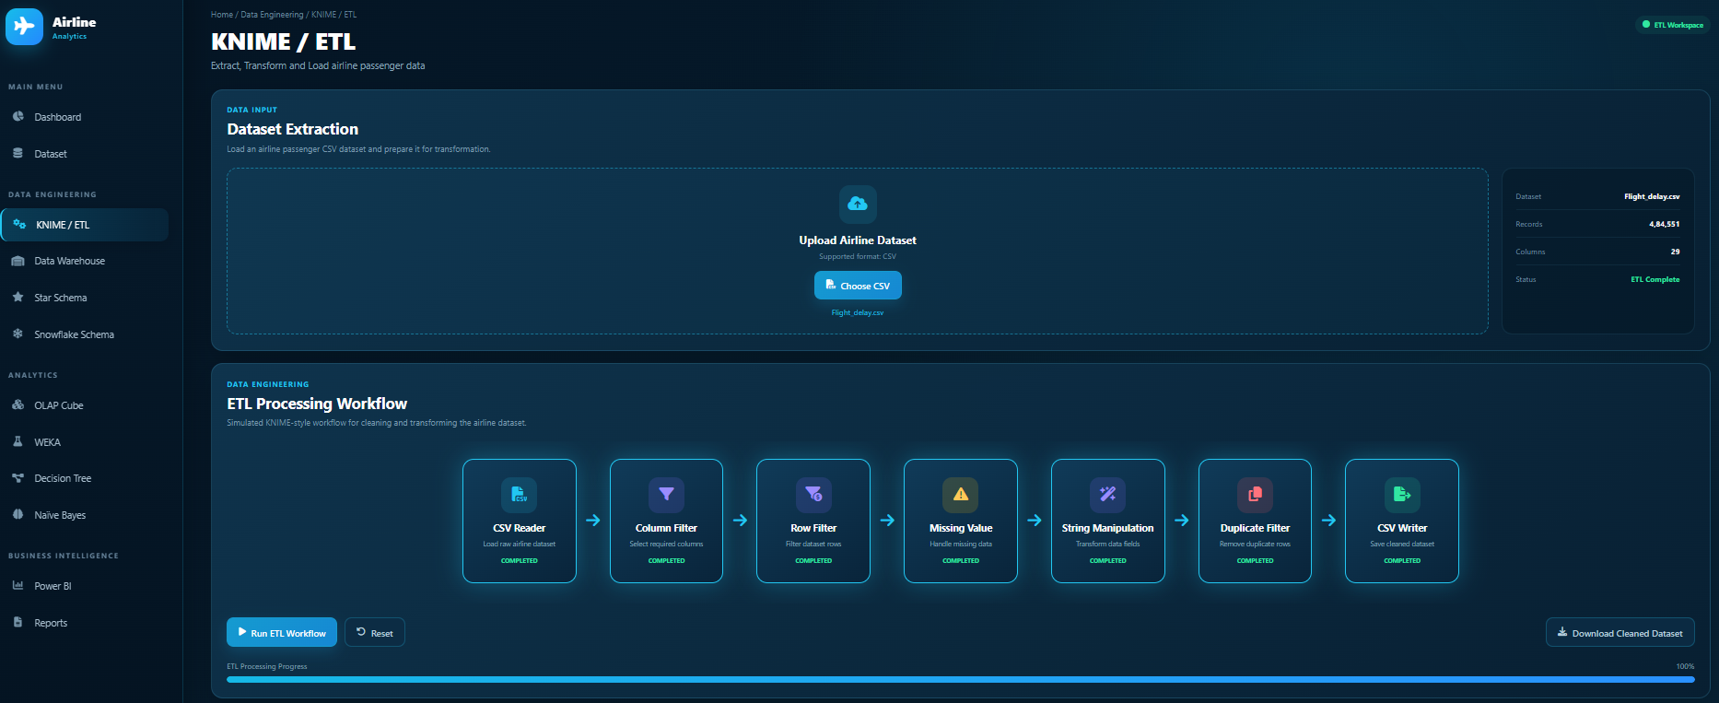 | 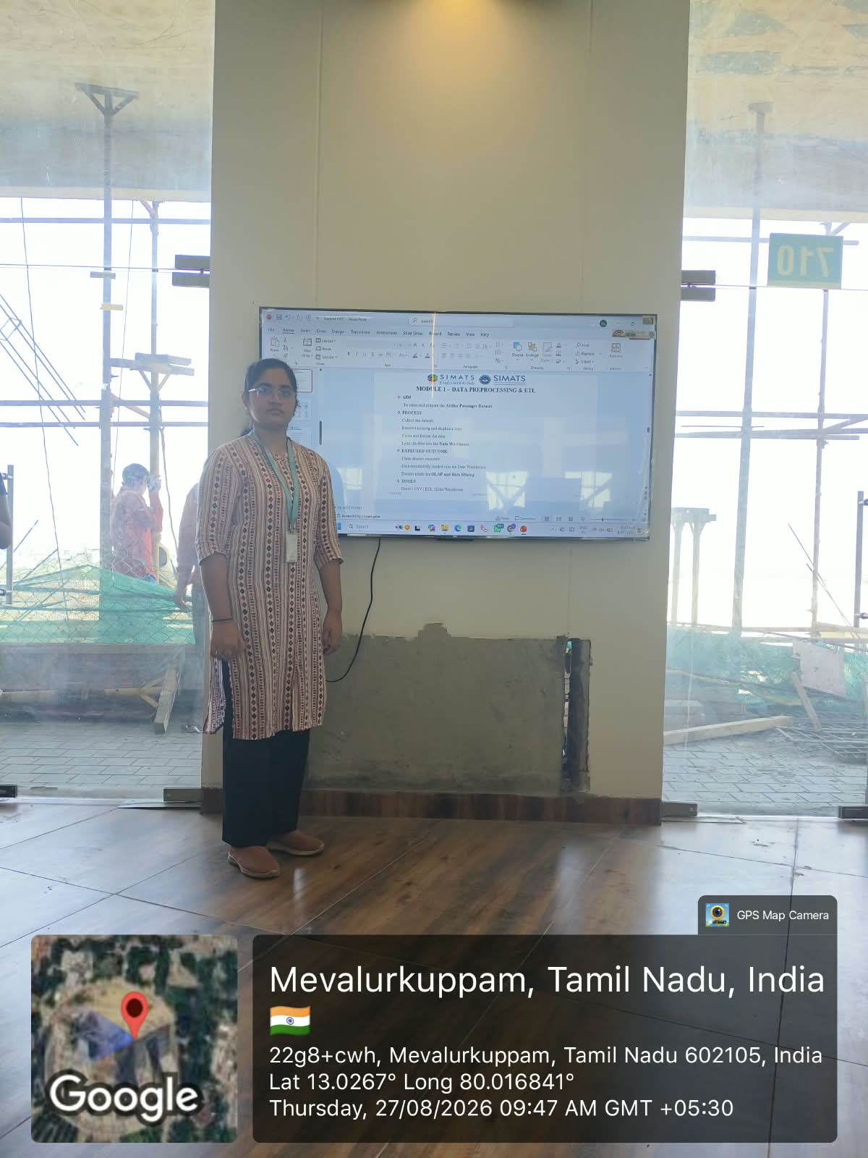
Project Description: Module 3- Screenshot Prevention, Screen Recording Detection & Download Control
The project “Airline Passenger Analytics using Data Warehouse, ETL, Decision Tree, Bayesian Classification, OLAP Cubes, KNIME, WEKA and Power BI” focuses on collecting, cleaning, transforming and organizing airline passenger data for effective analysis. The airline passenger dataset is collected from sources such as CSV or Excel files and is examined to understand passenger, flight and related information. The collected data may contain missing values, duplicate records, and inconsistent formats, which can affect the accuracy of analysis. Therefore, data preprocessing techniques are applied to identify and handle missing values, remove duplicate records, clean unnecessary information and standardize the required data. The ETL process is then used to extract the required data from the source, transform it into a clean and suitable format, and load the processed data into the Data Warehouse. The loaded data is validated to ensure that it is accurate, consistent, and ready for further processing. This module provides a reliable and structured dataset for the next stages of the project, including OLAP analysis, data mining, classification and Power BI visualization, helping to generate meaningful insights from airline passenger data.

Student Signature Guide Signature

